# 

# Hacker Rank – Account Creation and Understanding Problem

**Account creation:**

**Step 1:** The initialstep is to create a account in Hackerrank platform by visiting <https://www.hackerrank.com/>.

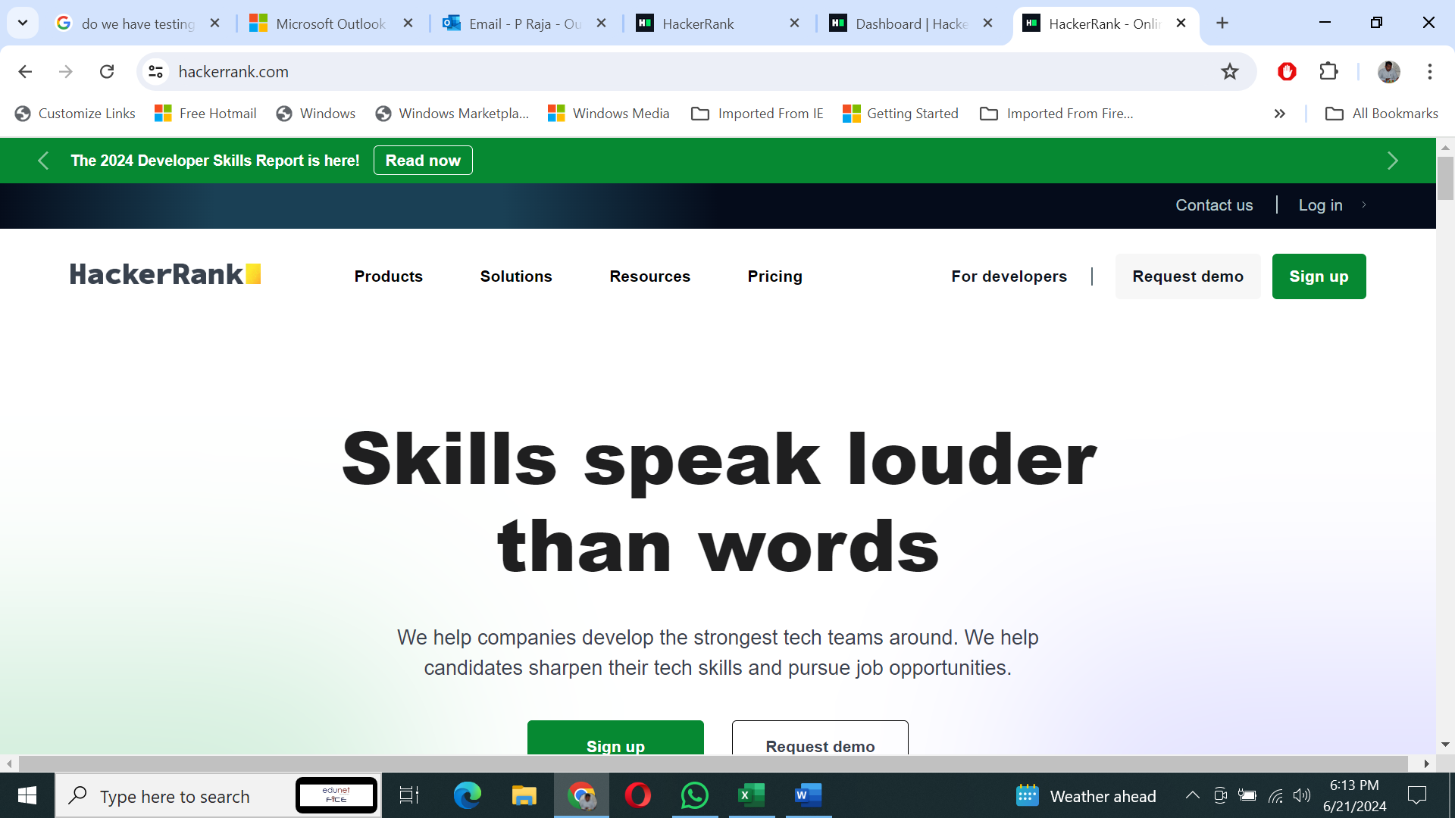

**Step 2:** Click on signup and select ***I’m here to practice and prepare*** after that click on create account.

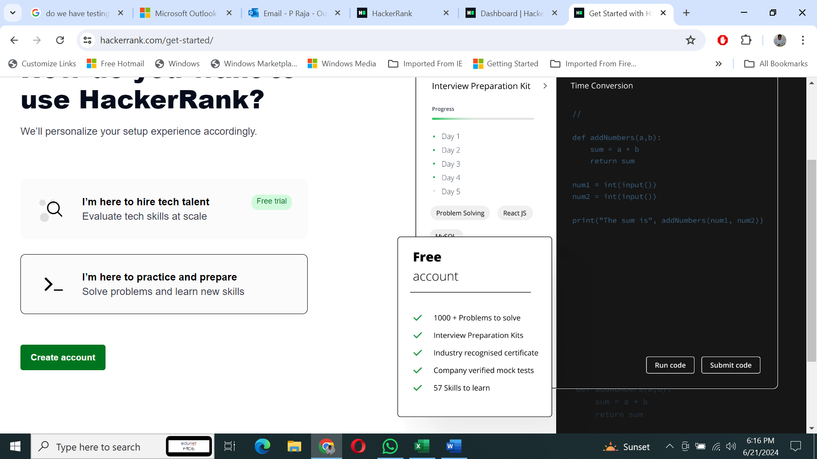

**Step 3:** In this page type your name, email ID and password as per your wish.

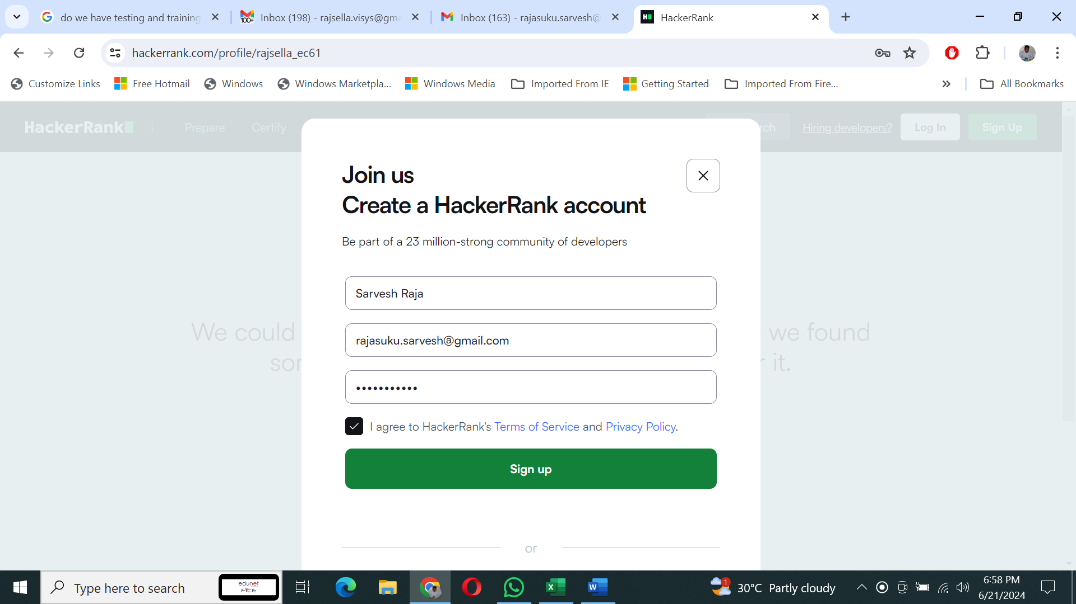

**Step 4:** In this page select learn & Compete with Others

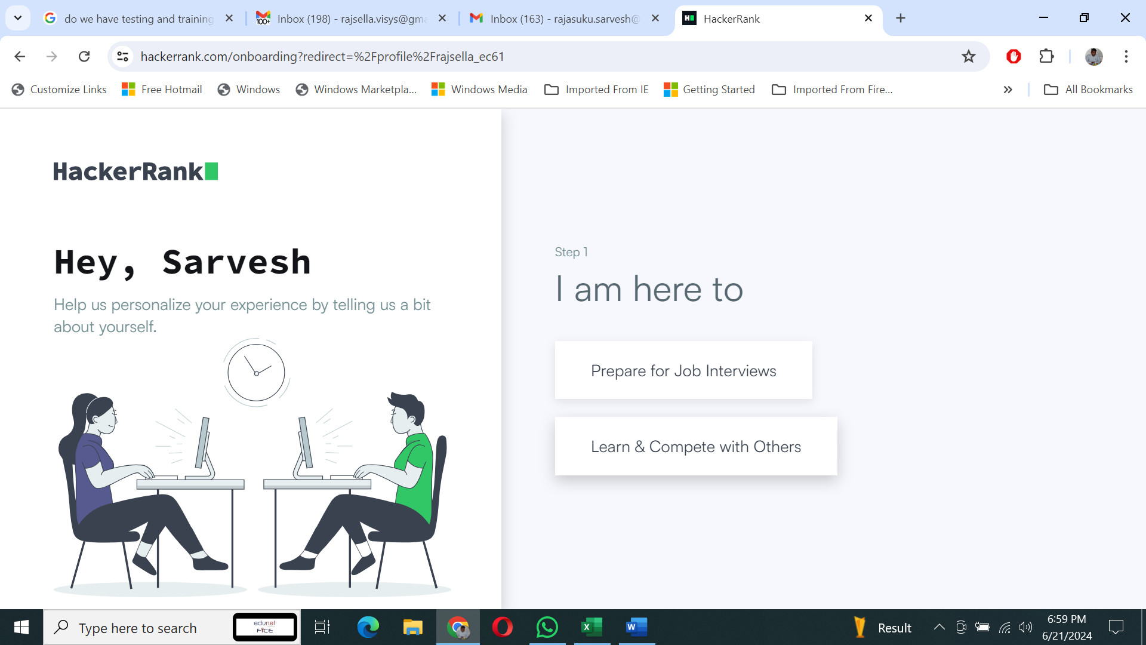

Step 5: Select Student

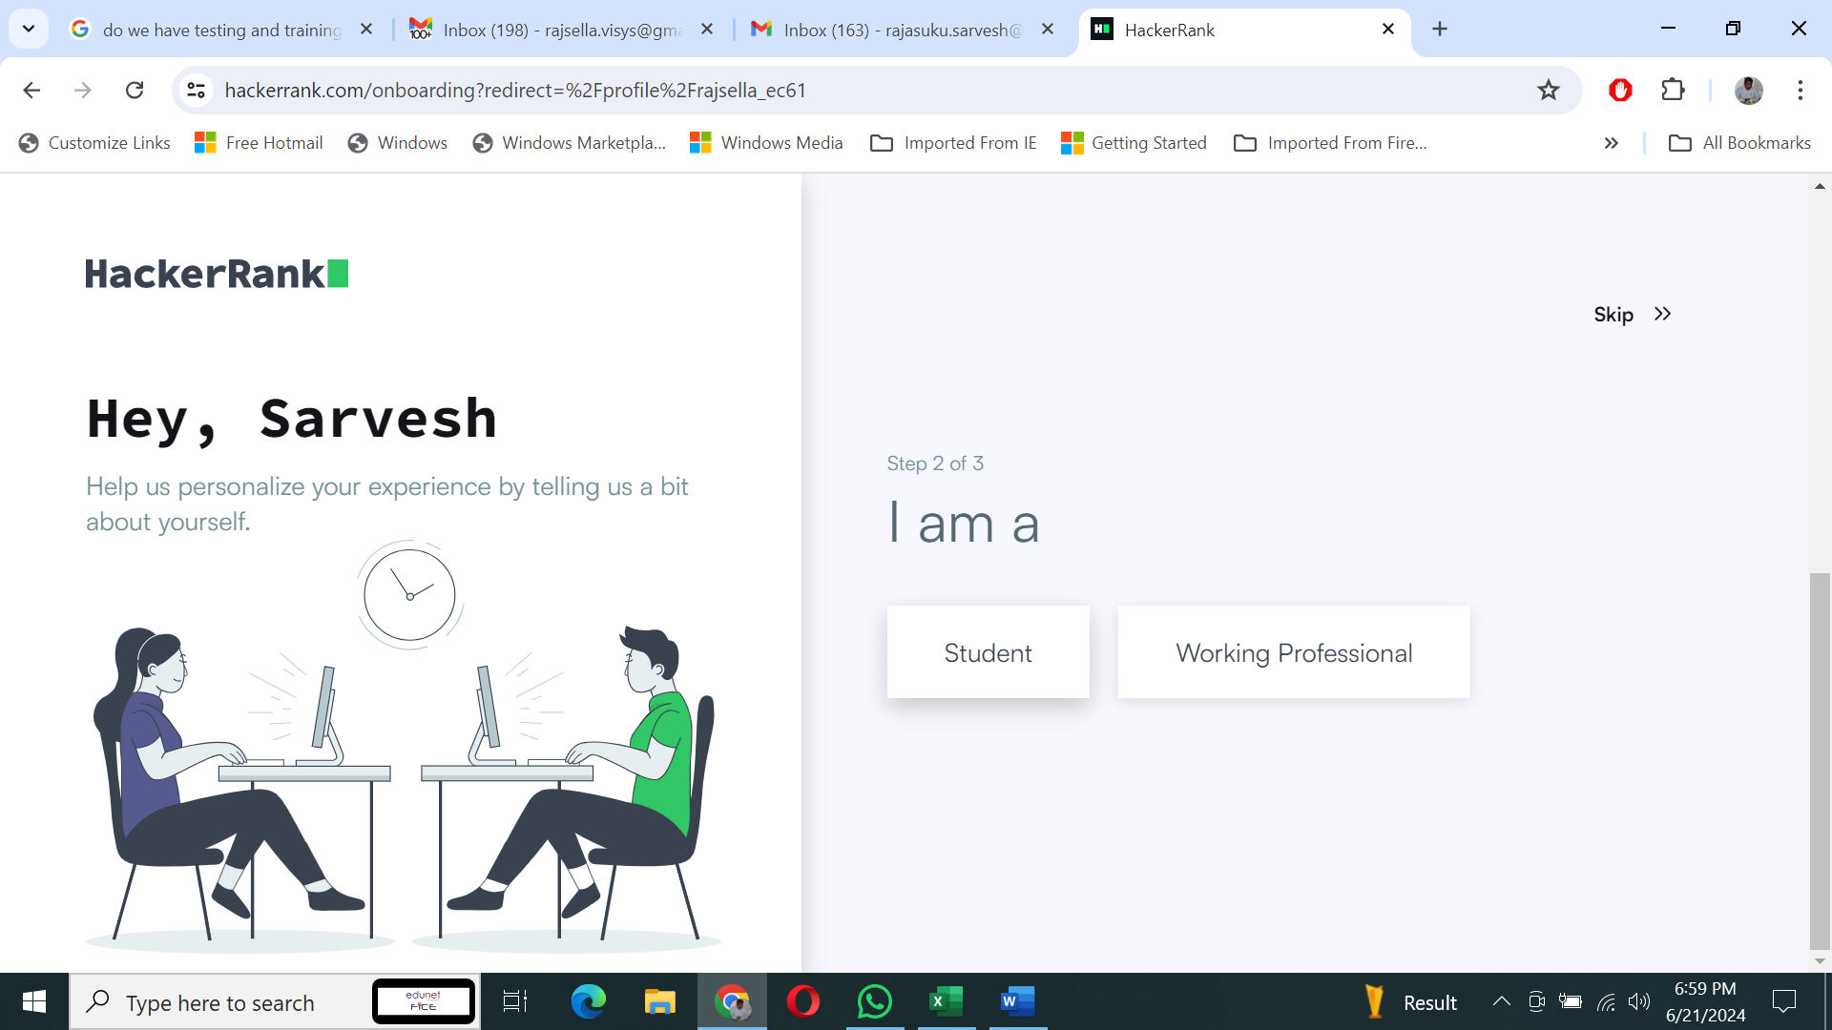

**Step 6:** Select your graduation year and click on lets go button.

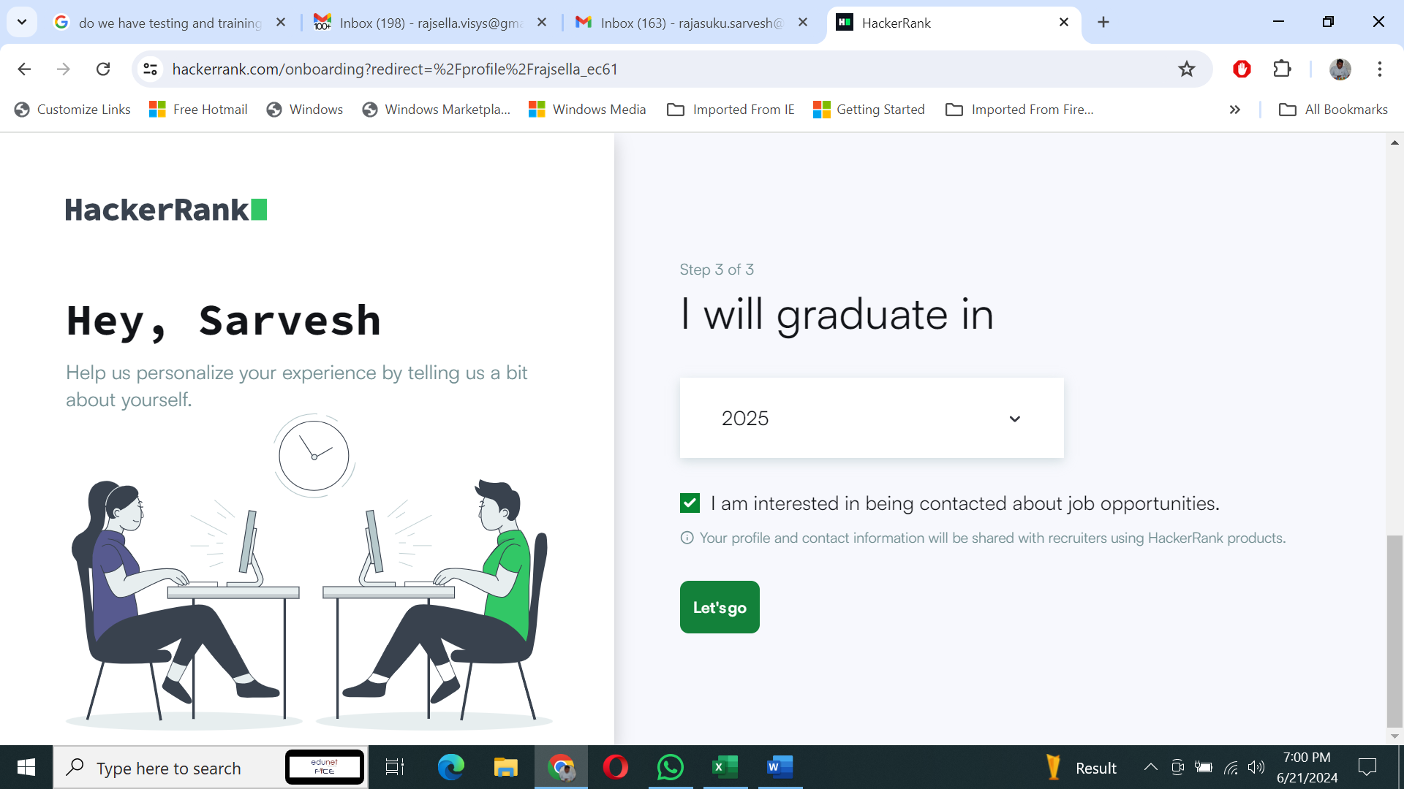

**Step 7:** Click on 9 dot which is on top right corner and select practice & contests

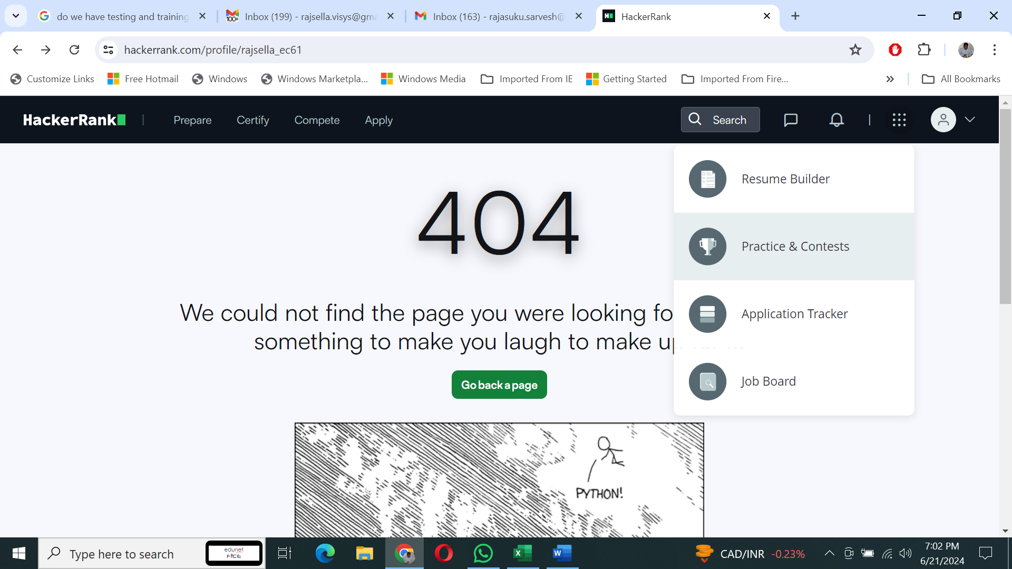

**Understanding the hacker rank problem**

**Step 8:** Here need to select any one of the the topics

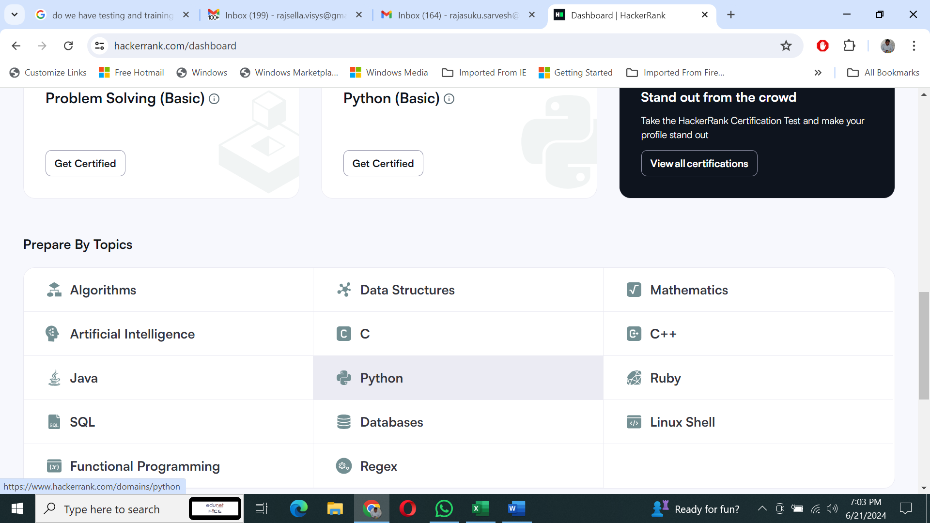

**Make understand to write the code in hacker rank**

**Step 9:** Here you can see multiple challenges in python programming.

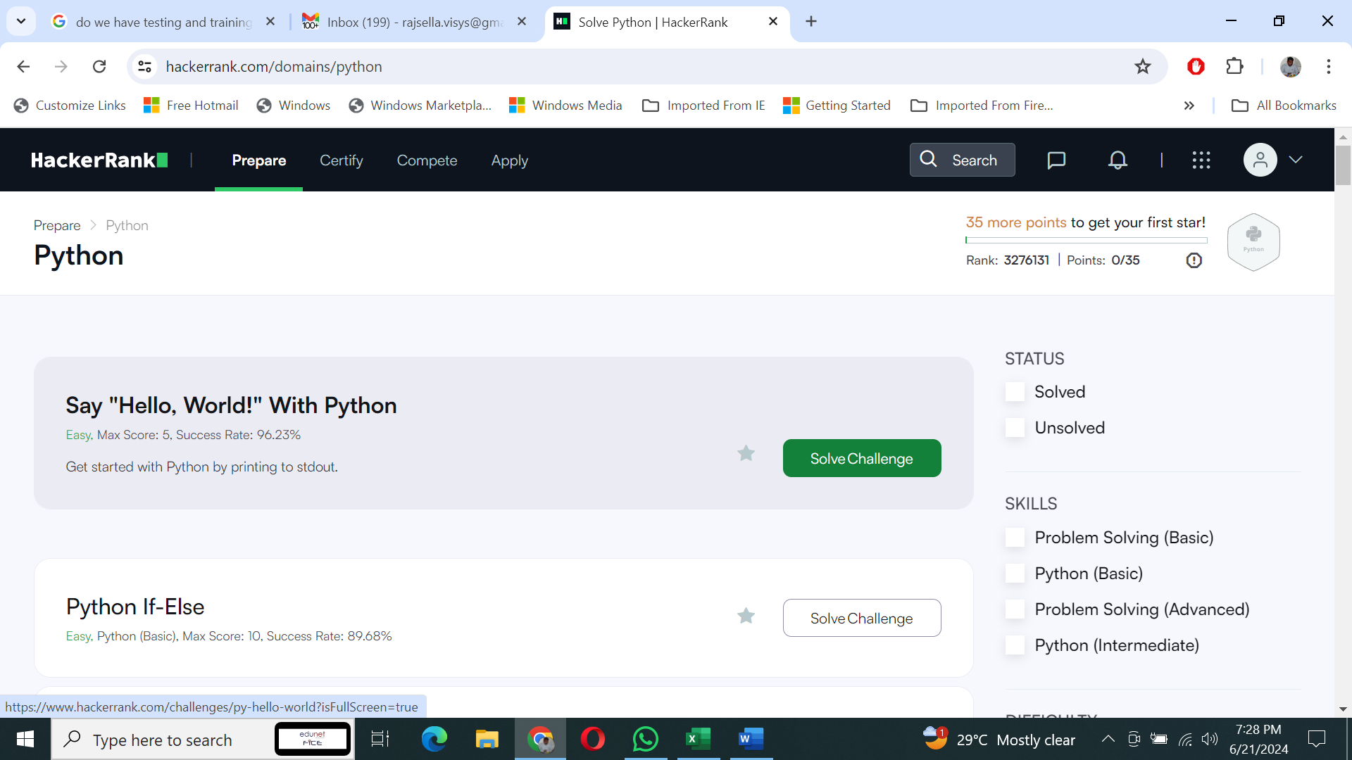

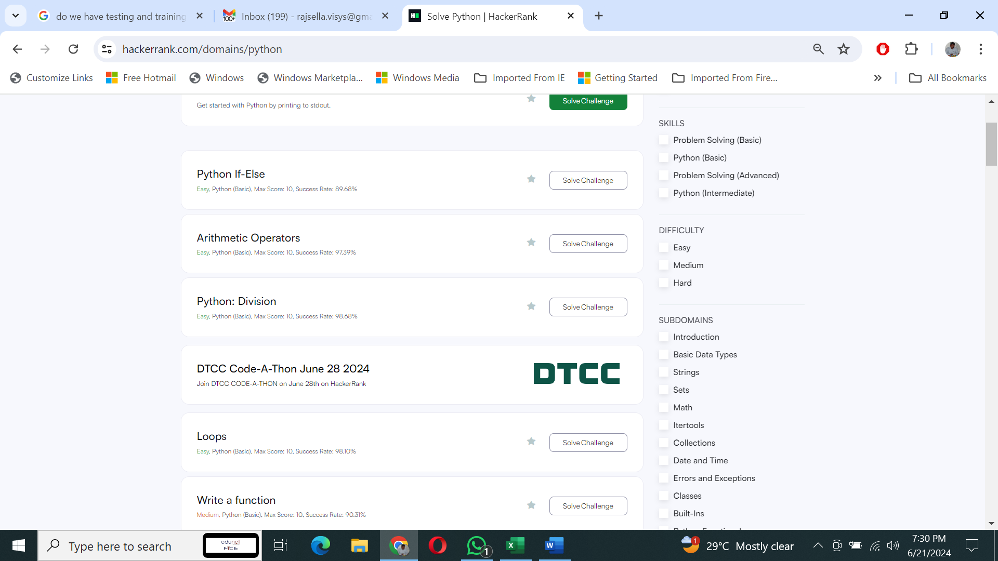

Step 10: Now you can select the “say hello world” challenge

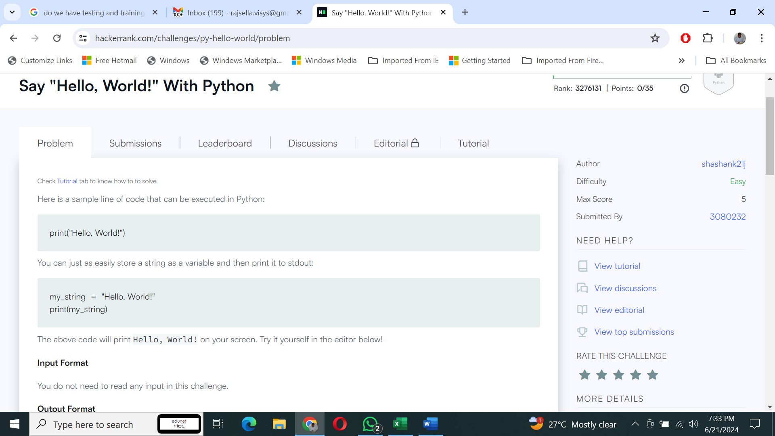

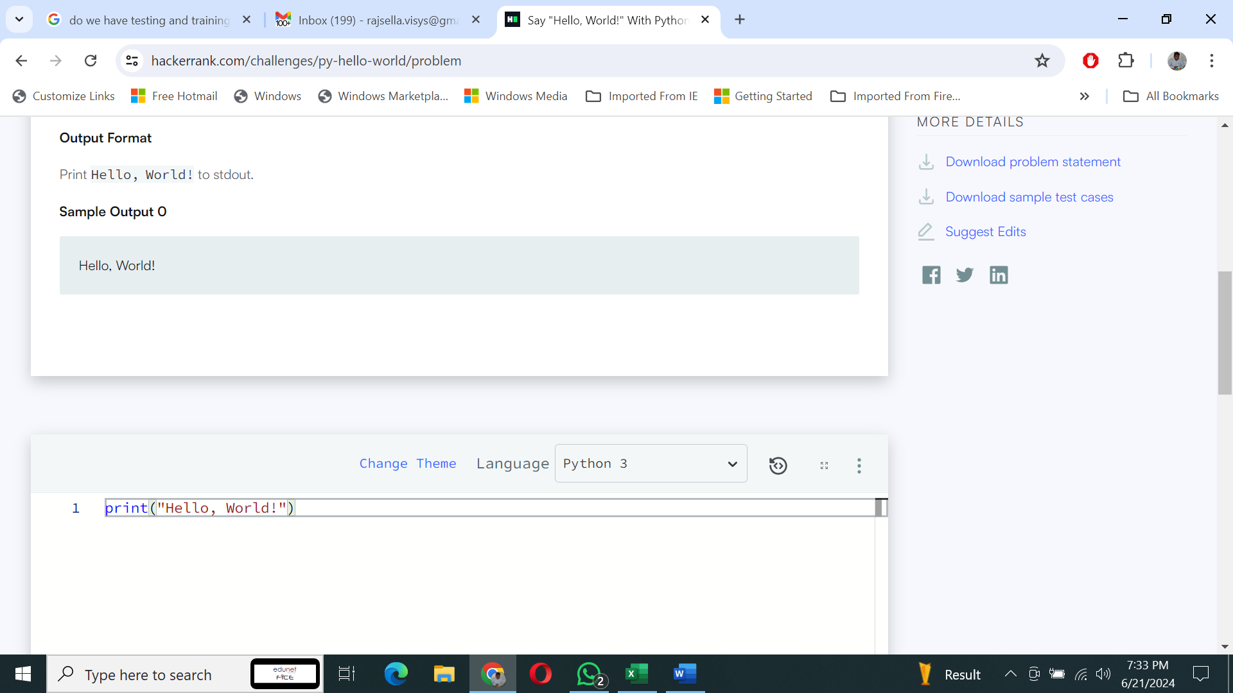

**Step 11:** After understanding the problem statement then you can solve the challenge.

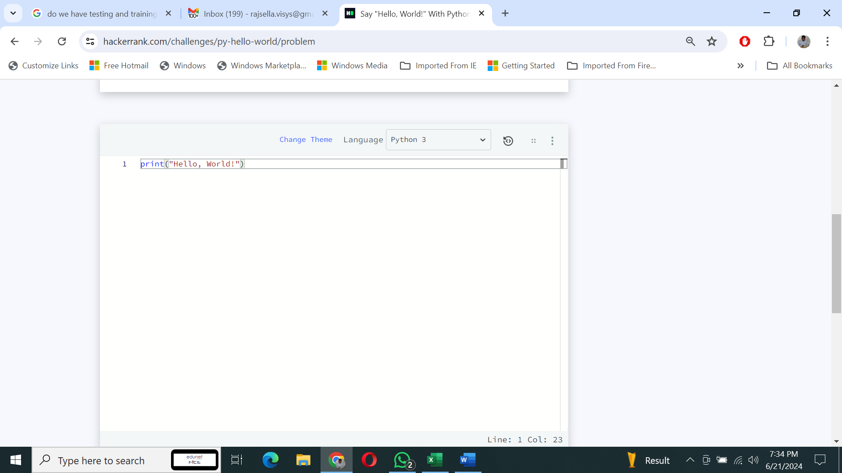

**Step 12:** Once you are done with the code click on run code to verify the code. If the code passes all test cases, then you will get a congratulatory message otherwise an error message will be displayed.

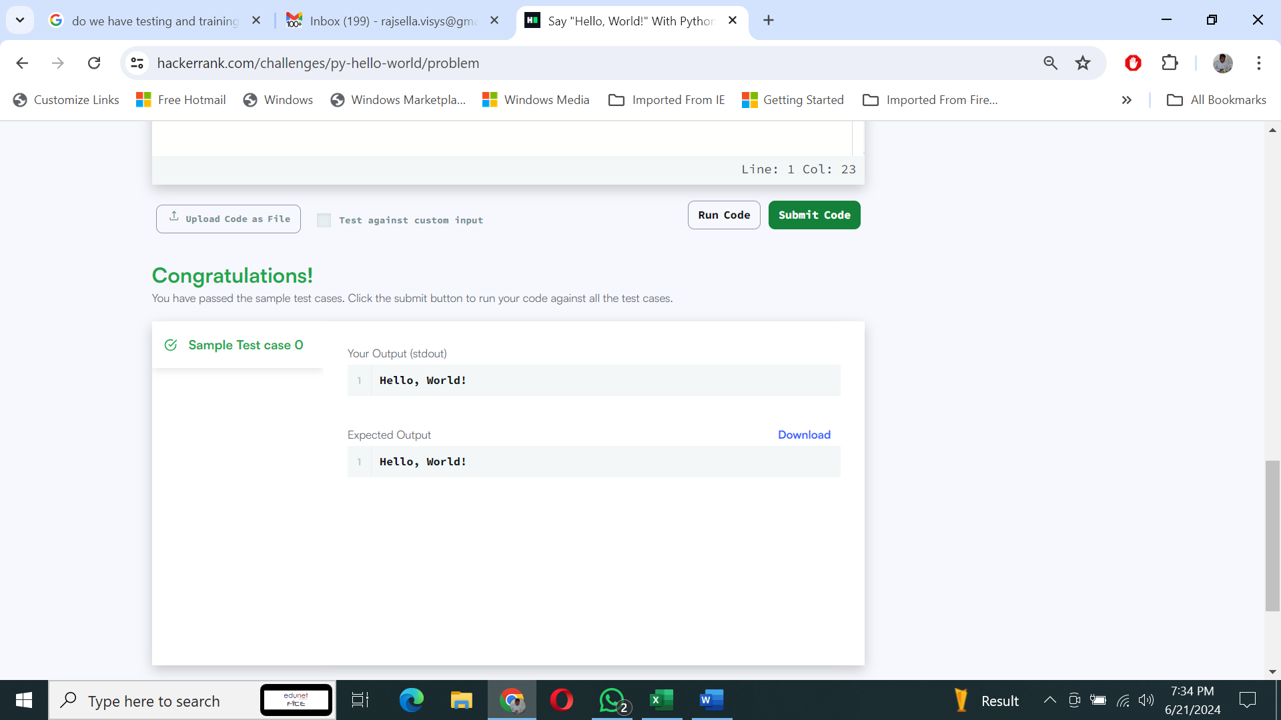

**Step 13:** The submission status and score will be updated once you click submit code button.

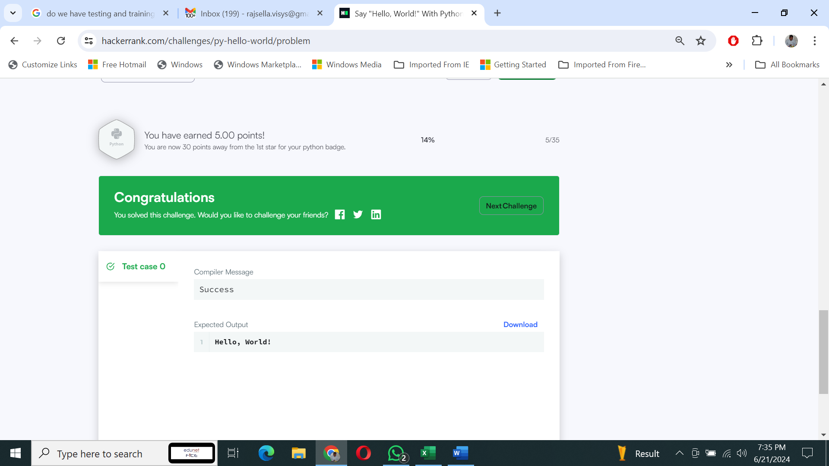

# String Split and Join

Understand the problem statement.

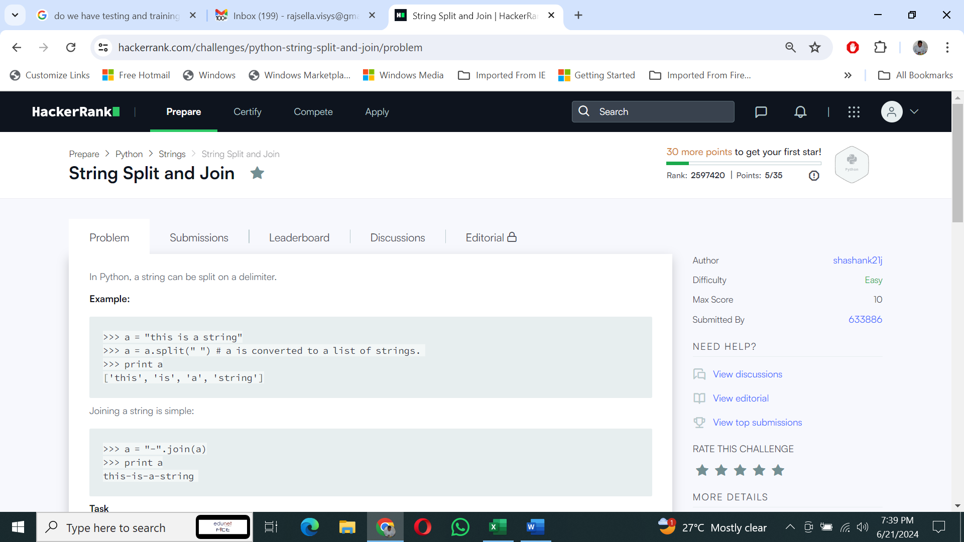

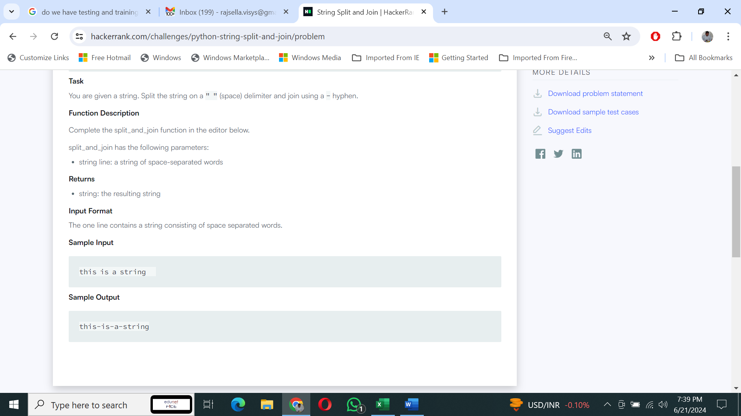

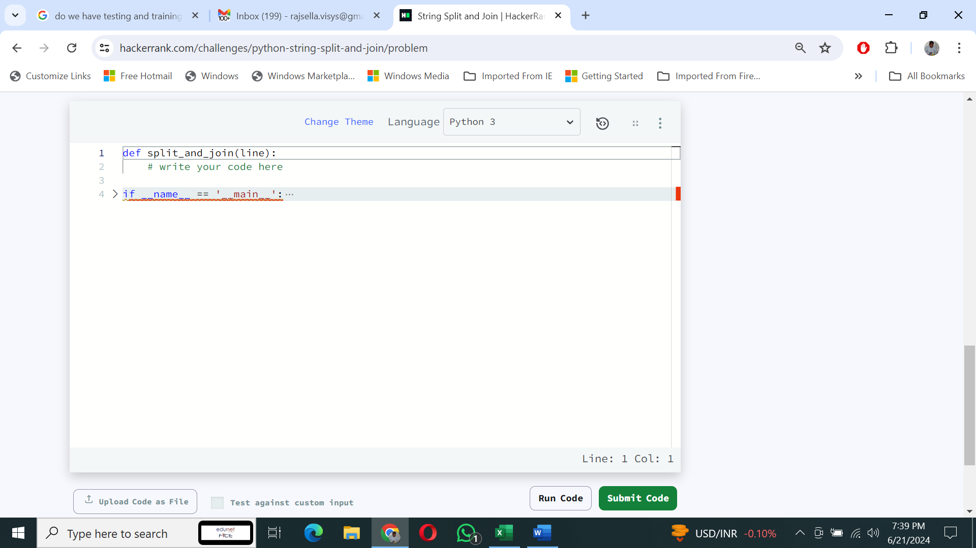

Write your code here

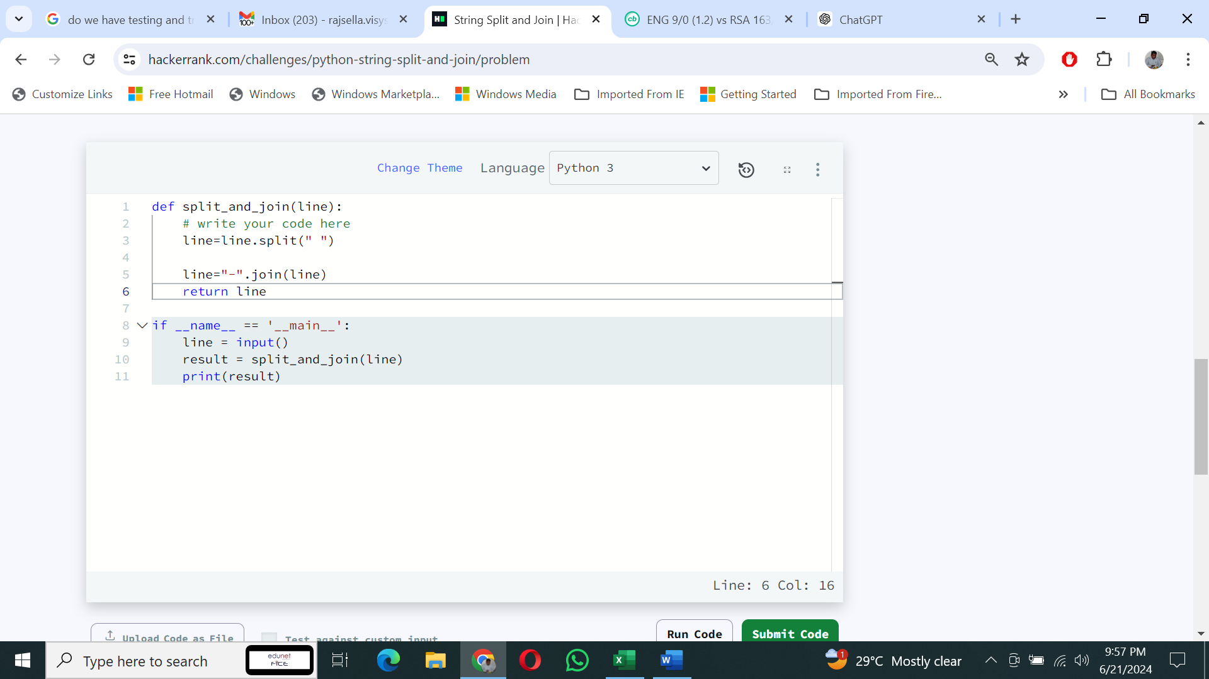

Click run code and check the execution status.

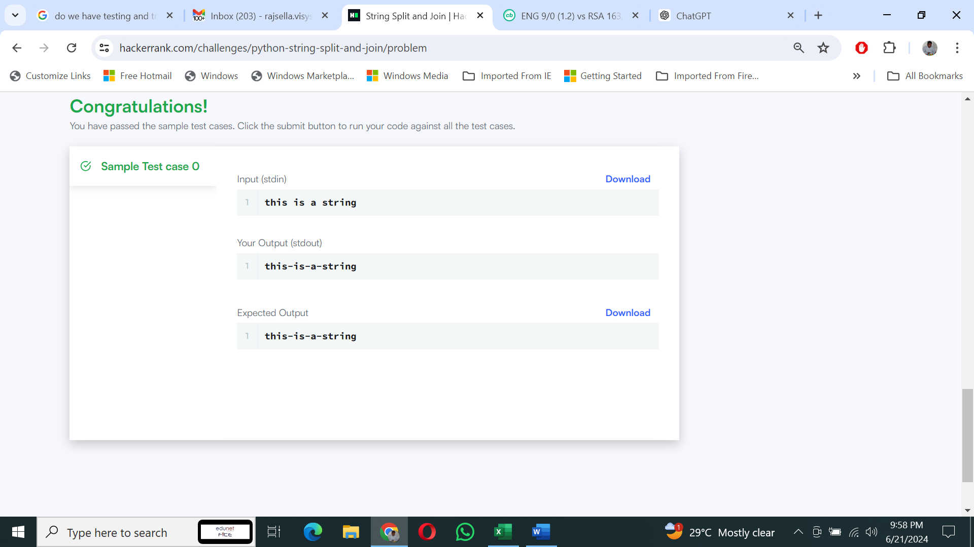

Once verified the code you can click on submit code button.

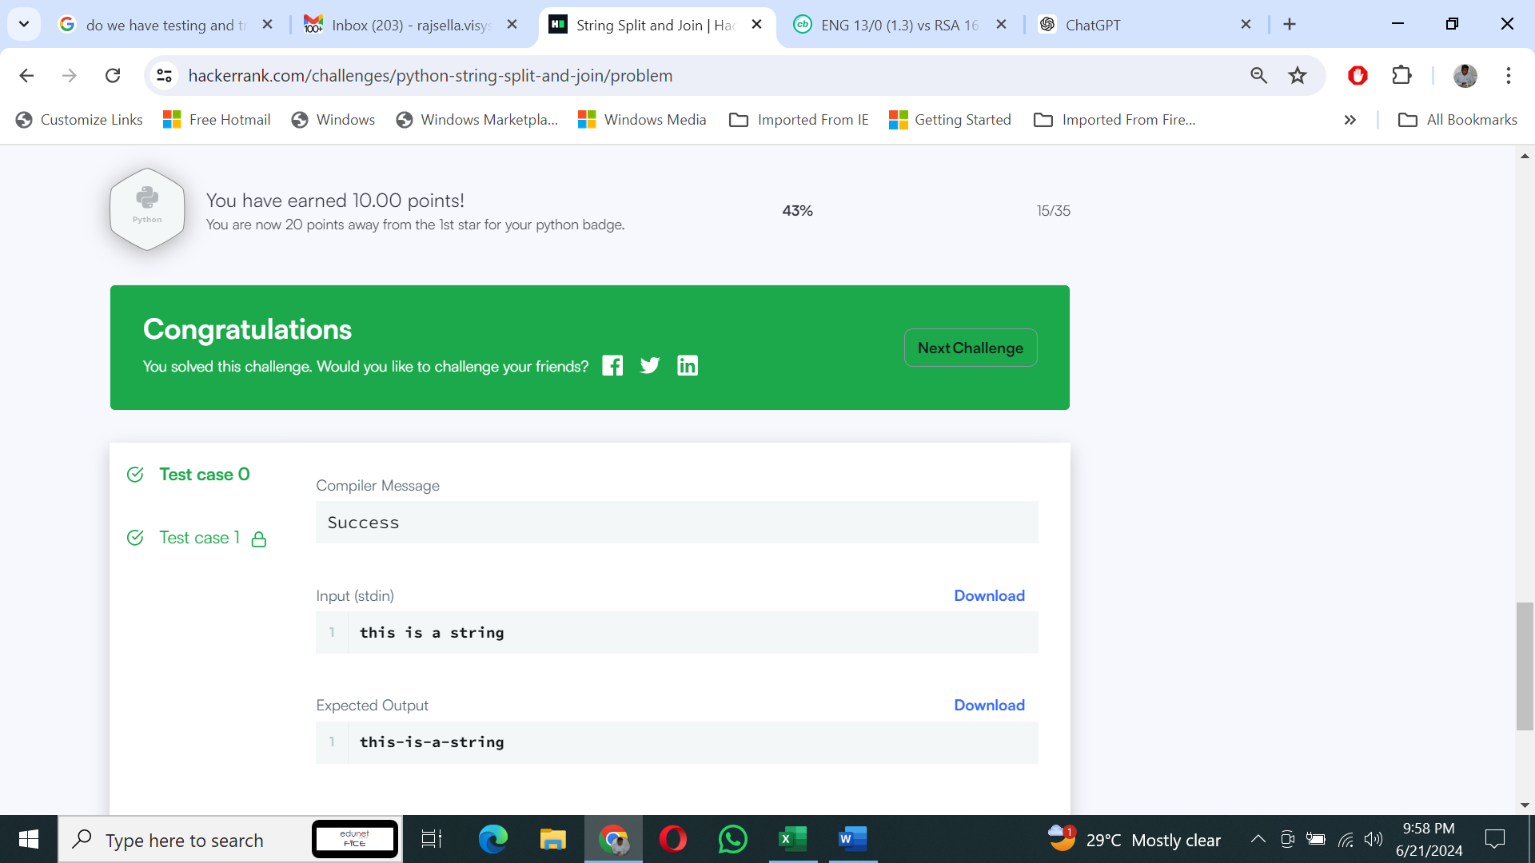

For the upcoming topics you have to follow the same steps which we followed for the previous challenges.

**Set:**

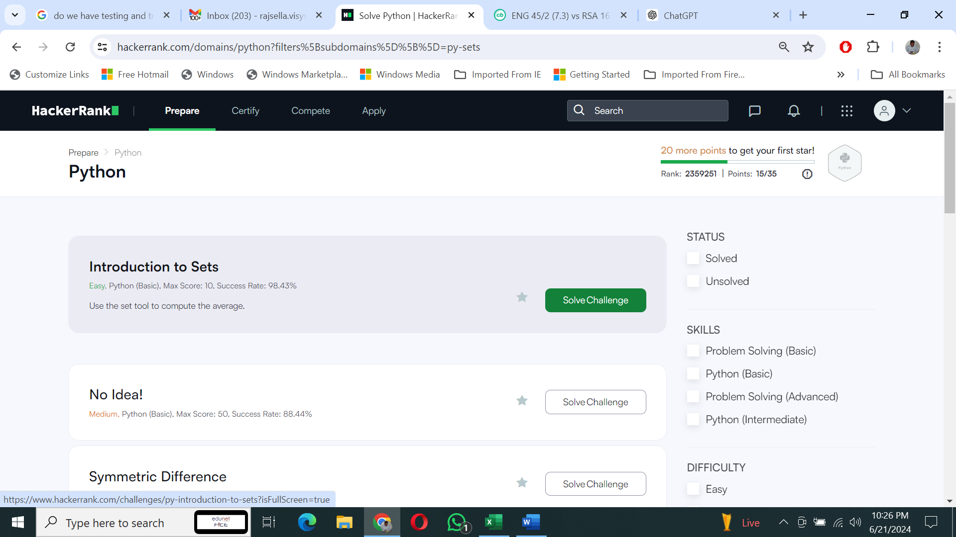

**Math:**

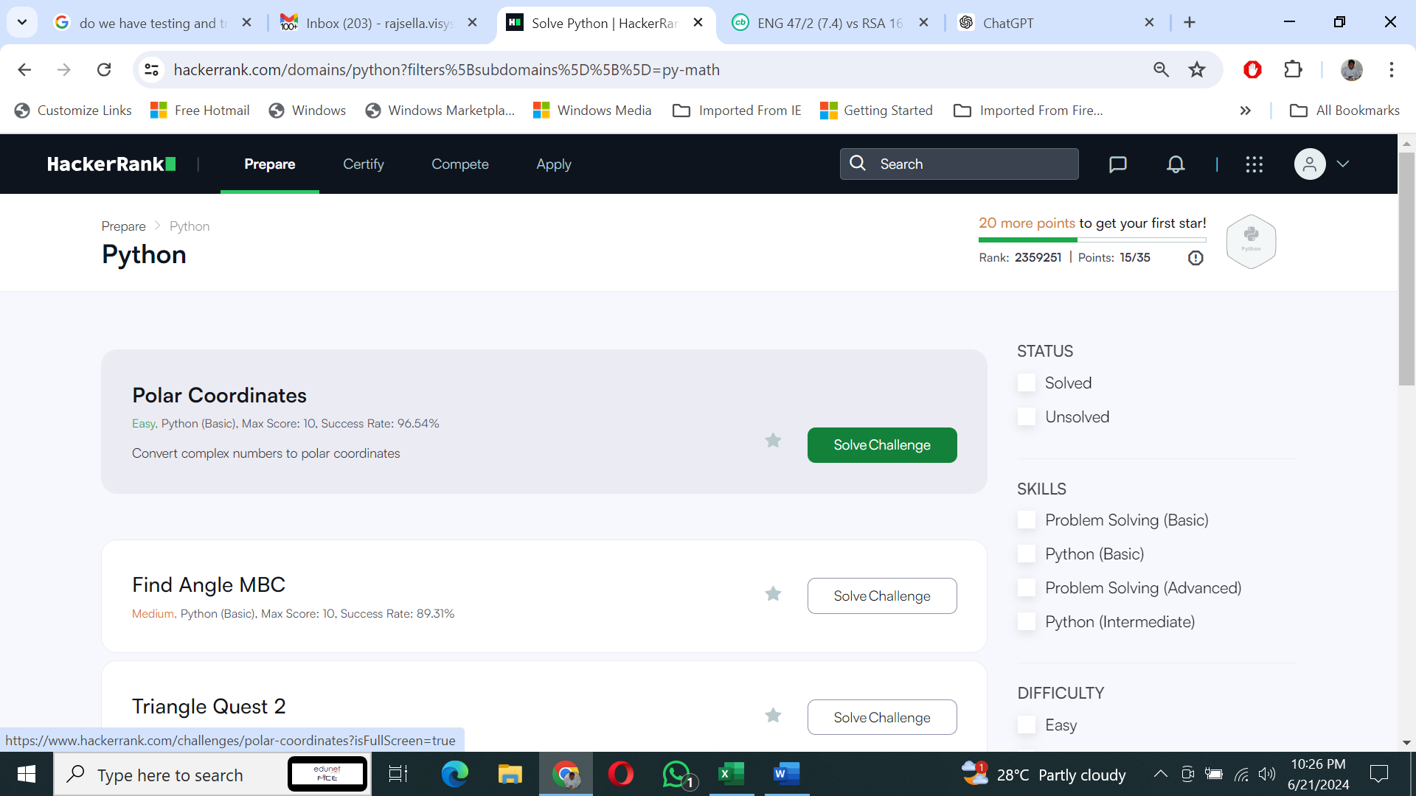

**Itertools:**

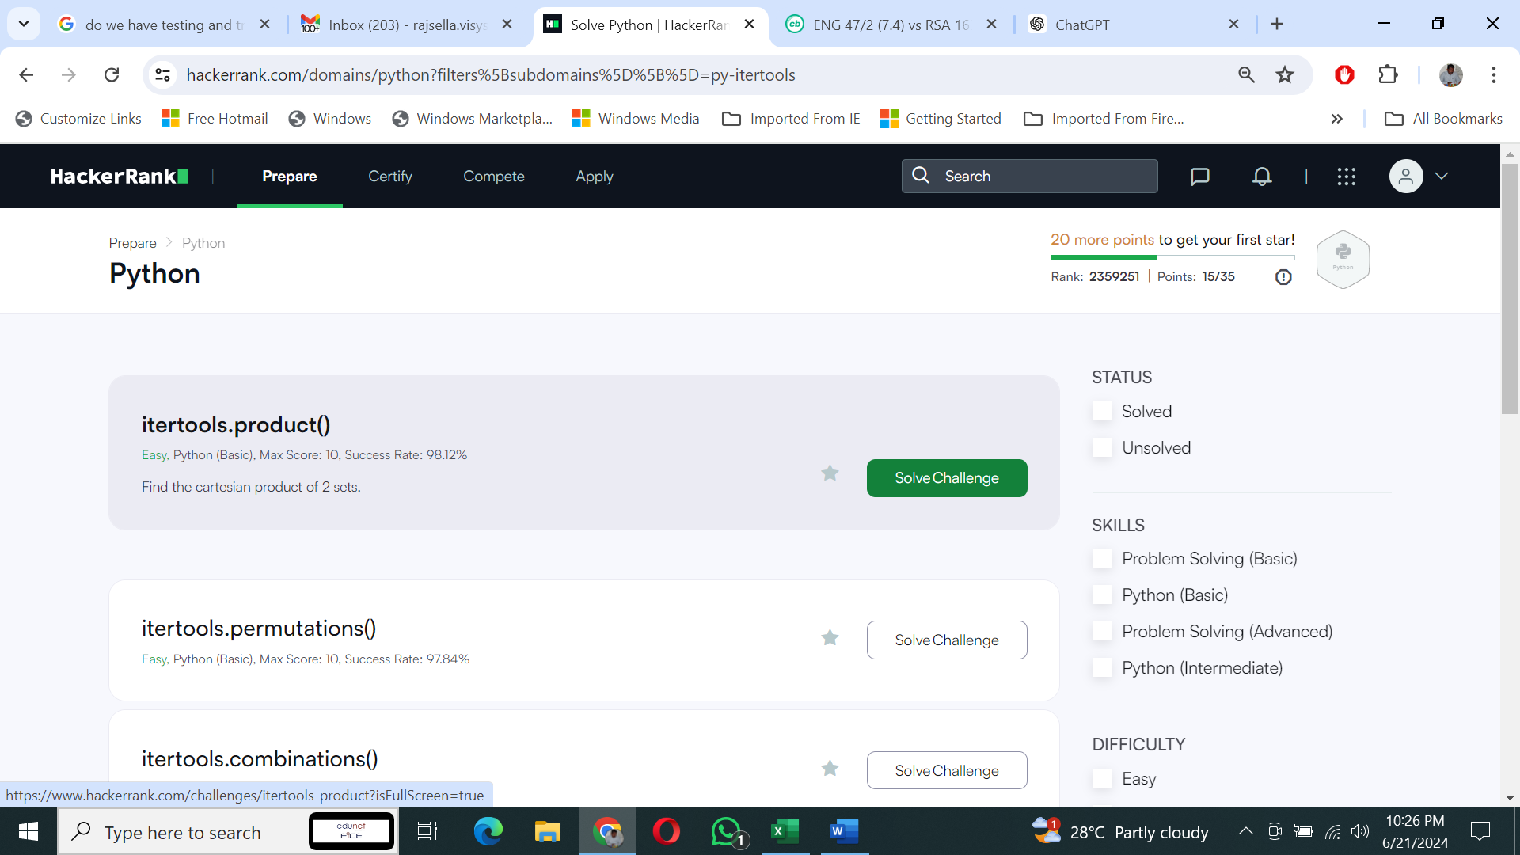

**Collection:**

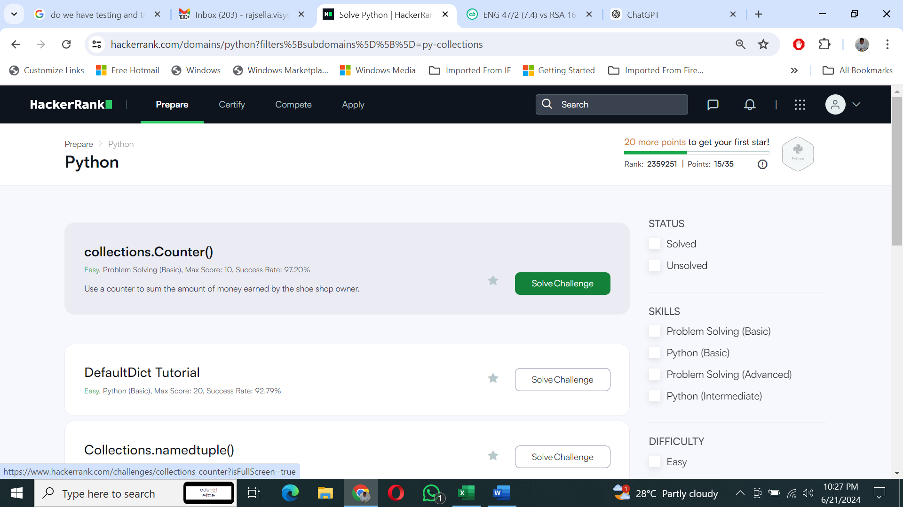

**Date and Time:**

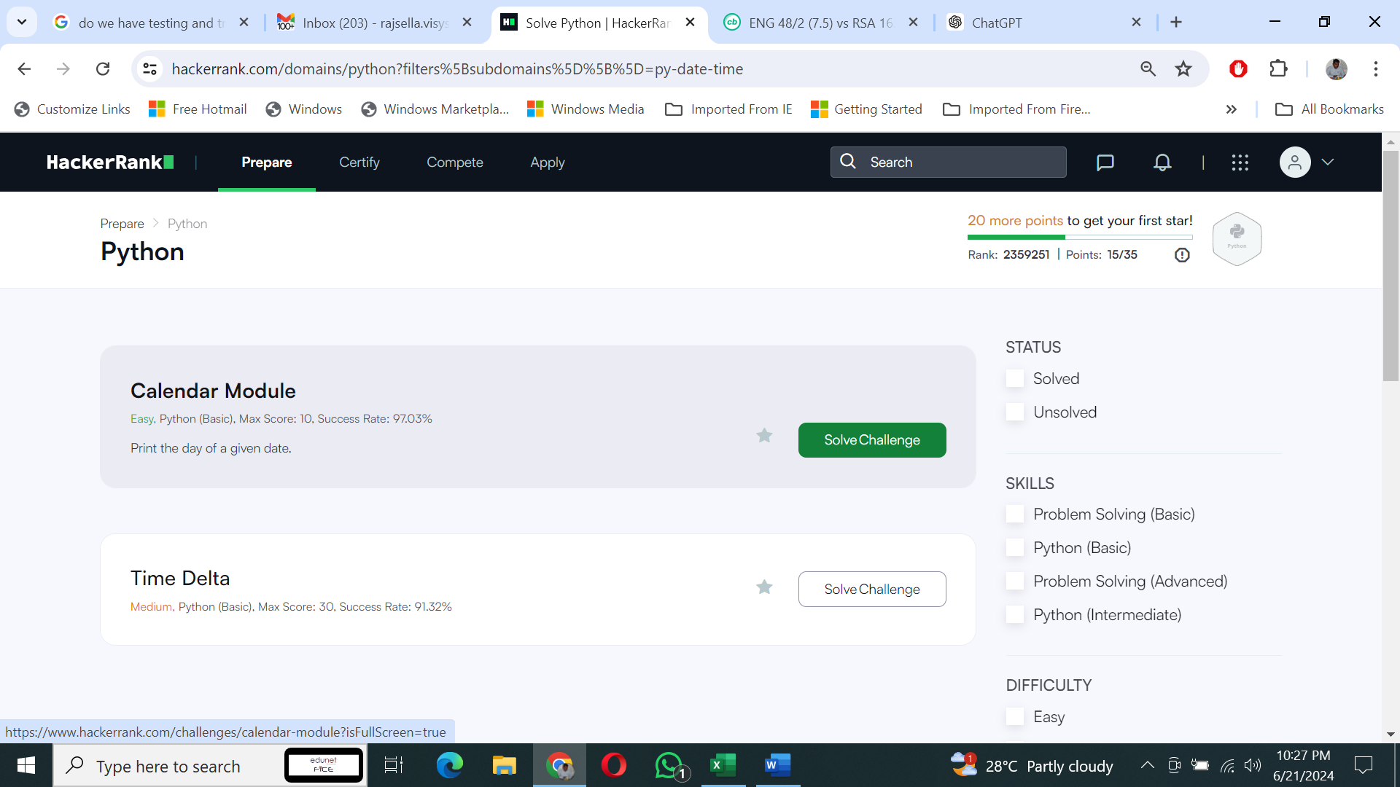

**Class:**

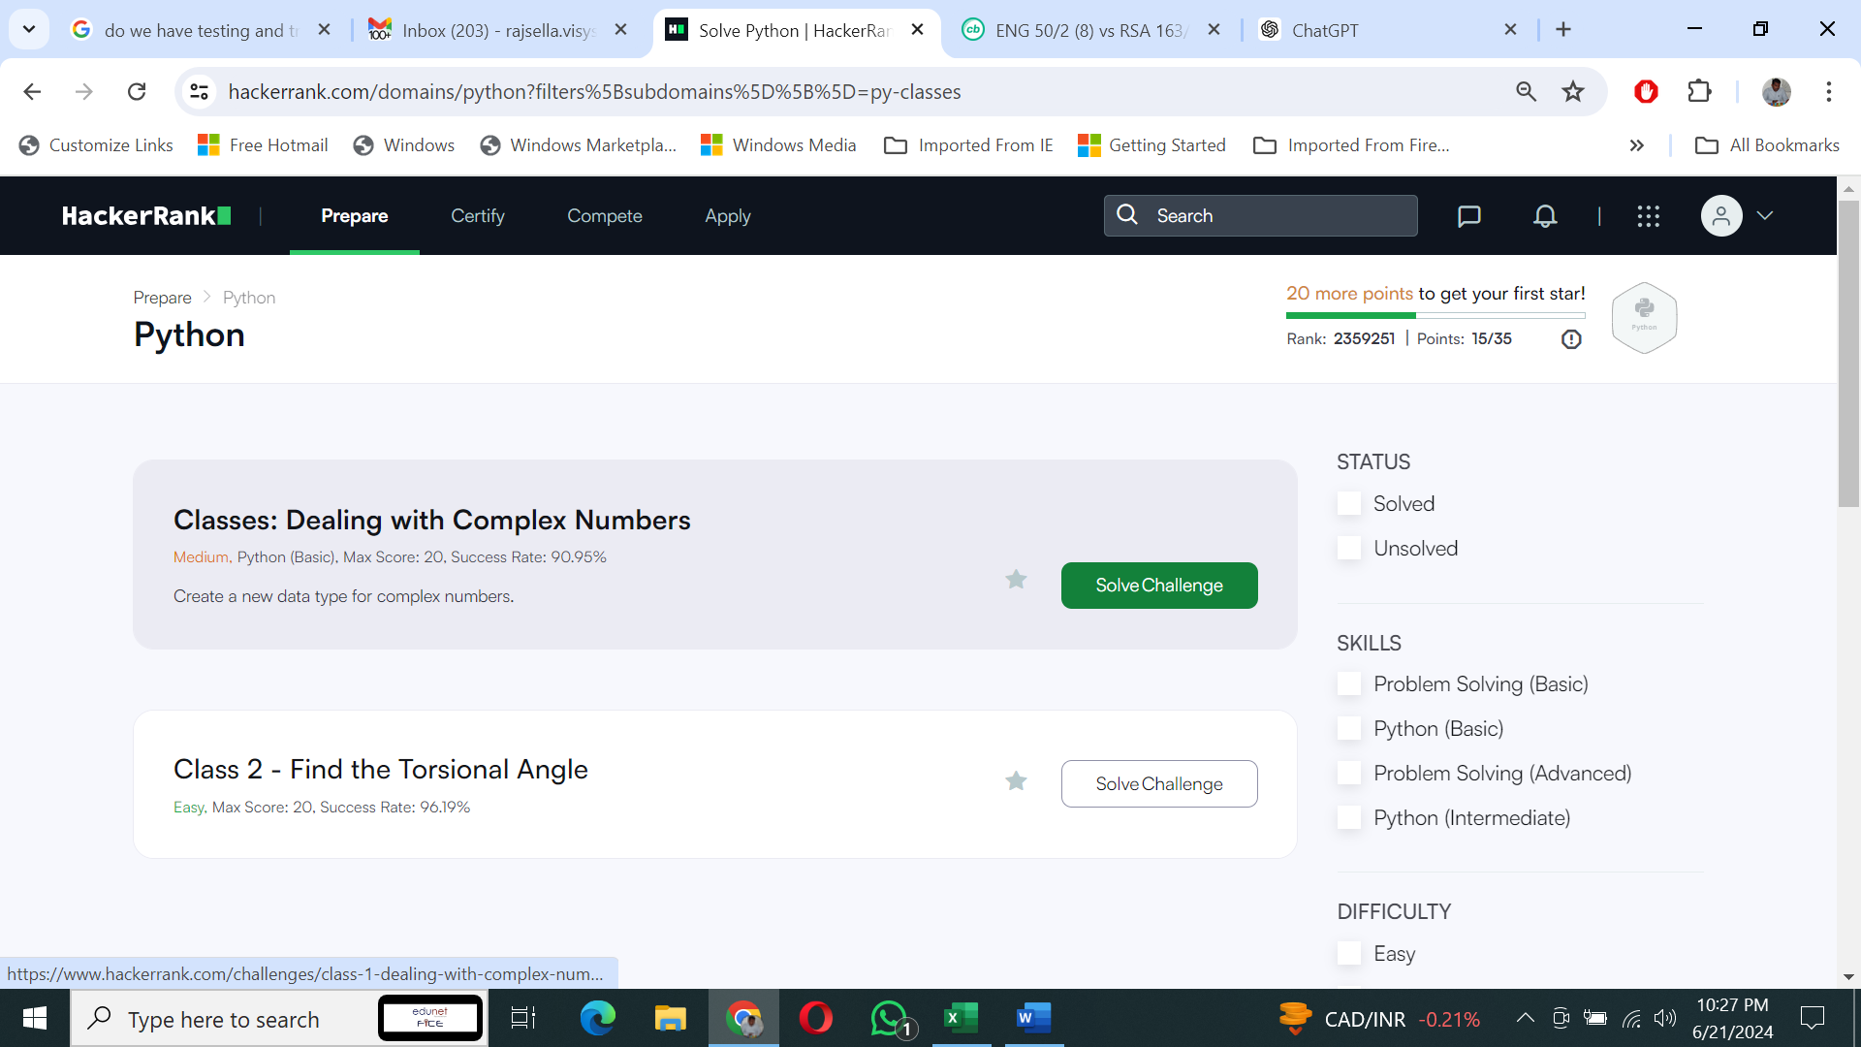

**Built Ins:**

